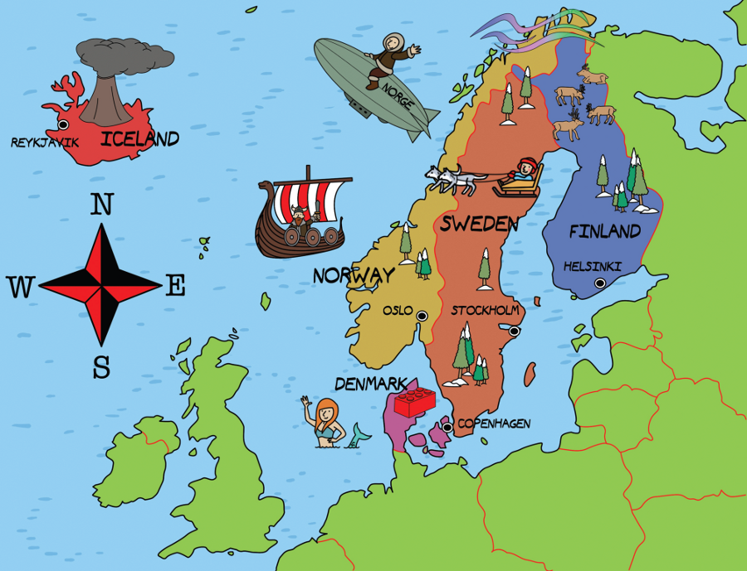
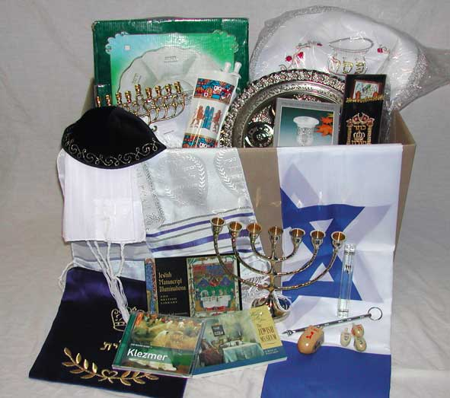
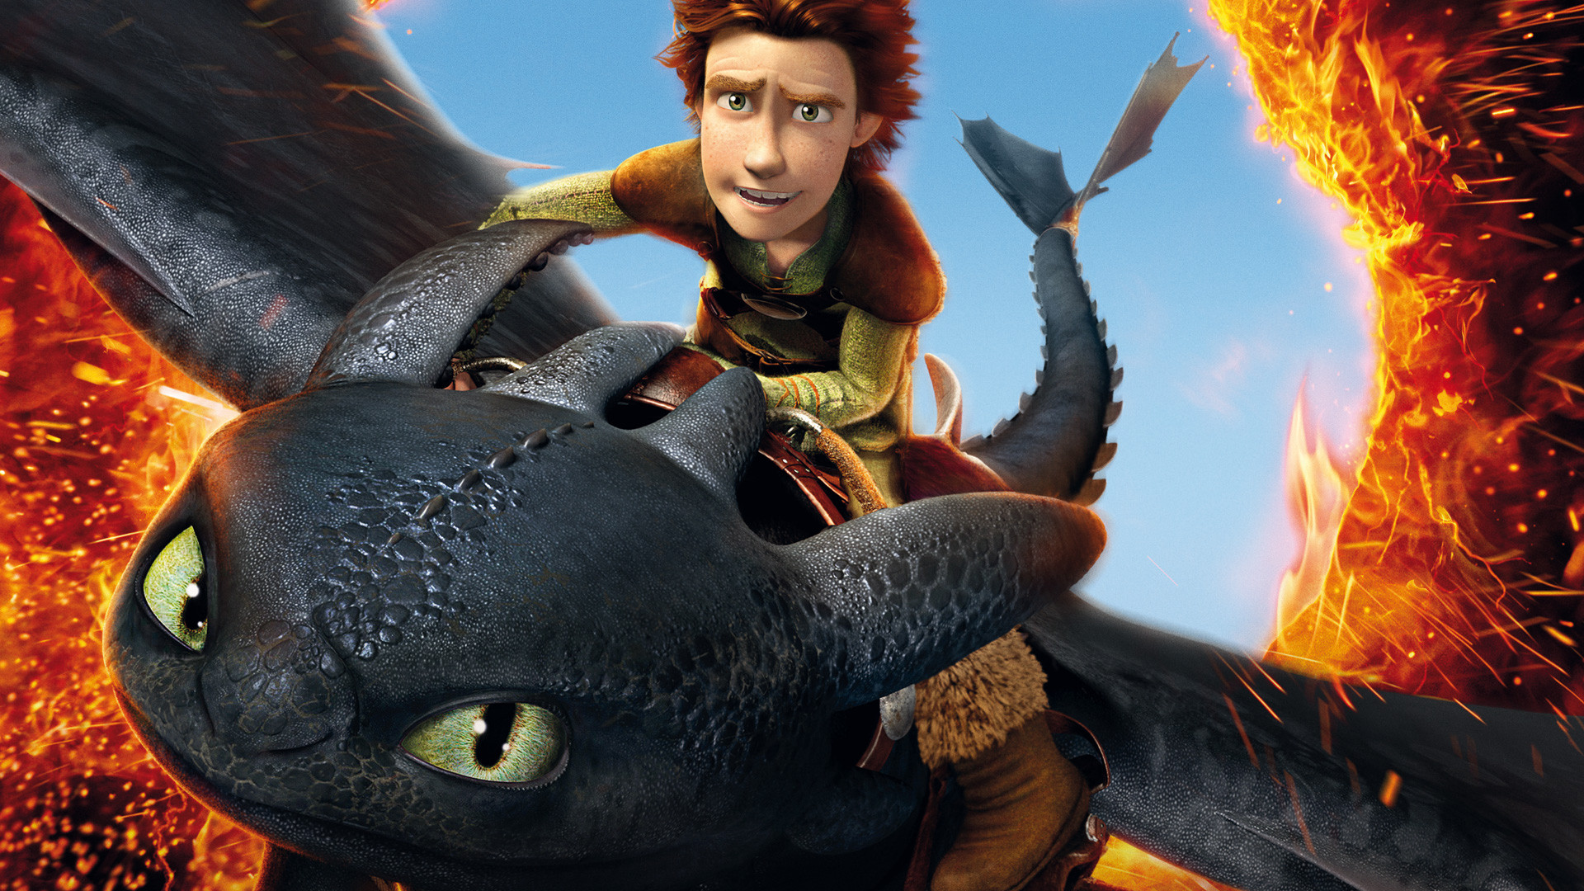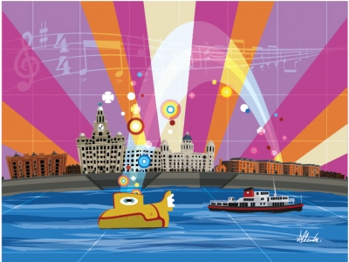
National Curriculum

As historians we will learn about the history of the Vikings in Britain.
This will include: exploring who they were, why they came to Britain, what their culture and home-life was like, which gods were important to them and who their key leaders were.

As geographers, we will locate where the Vikings came from and went to on a map and note the significance of choosing Britain to invade. We will also describe the physical characteristics of where they lived.

In D.T. we will design our own pair of Viking shoes using a variety of sewing techniques and materials.

In Art we will use Viking runes as inspiration for a collaborative piece of work.
Medium Term Planning Term - Spring 2 Year Group - 6 Topic - The Vikings
Speaking and Listening

We will hot seat different Vikings following research into their lives.

We will discuss whether Vikings were Raiders or simply Traders.

Writing Opportunities

We will write as if we are a Viking estate agent and persuade someone to buy a homestead.

We will create a guide for a tourist exploring the Viking city, Yorvik.

Maths Opportunities

We will use measurements to help us design a Viking longboat and a pair of shoes.

We will create a timeline showing what the Vikings did in Britain.

Social, Moral, Spiritual,
Cultural
We will learn about what life was like in a Viking village and how food and fashion has changed since that time.

We will explore our feelings when we read the stories about what the Vikings did to some monasteries.

In R.E. we will be studying the religion Easter in Art.

