Year 1 Isolation Pack
It is important that each day you follow a routine and your child is up, dressed and ready to learn by 9am. Make sure before this they have had a healthy breakfast then find a calm, quiet space for them to start learning, ideally sat at a table. Make sure throughout the day your child has regular short breaks and the opportunity to take part in daily exercises.
Example Timetable and Daily Routine
9:00 | Mindfulness | Start each day with a mindfulness activity (included in pack) which will prepare your child for the days learning.
9:15 | Reading | Follow this with 30-45 minutes reading either using the books provided, books you have at home or Bug Club (www.activelearn.co.uk). Help your child to apply their reading strategies such as sounding out the word, looking for phonic sounds within the words and breaking the word down into parts. During this reading time you should use the question prompts (included in pack) to ask your child questions about the text.
10:00 | Phonics | After reading spend 20-30 minutes practising phonics with your child. Use the sound mats (included in pack) to practise all the phase 2 and 3 sounds. This can include saying the sounds with the action and writing the sounds using neat cursive handwriting. Then practice writing words which include these sounds and then writing the words in sentences.
10:30 | Break time | Encourage your child to have a healthy snack and get active for 15-20 minutes. Either take a run around outside or put some yoga (Cosmic Kids Yoga – youtube) or Just Dance Kids (youtube) on and get moving. It is really important for them to take a break and get their heartrate up as this will relax them and get them ready to continue learning.
11:00 | Literacy/Maths | After an active breaktime your child should settle down again to complete one of the maths or writing tasks (included in pack). This should be completed in pencil and completed to a high standard.
12:00 | Lunch time | Make sure your child has a healthy, balanced lunch and then gets active again - Cosmic Kids Yoga (youtube) or Just Dance Kids (youtube)
1:00 | Maths Dictionary | Start your afternoon learning with Maths Dictionary. Ask your child to read through each of the slides and practise the actions.
1:20 | Science/Topic | Follow this with a science or topic activity (included in pack).

Useful Websites and Apps | www.twinkl.com  www.bbc.co.uk/bitesize/levels – BBC Bitesize Website have a range of interesting and useful games and resources  https://beinternetawesome.withgoogle.com/en_uk/interland - internet safety  www.phonicsplay.co.uk – This website has lots of useful phonics games for all phases  www.purplemash.com  www.activelearn.co.uk  www.merseyparkprimary.co.uk  https://twitter.com/mpps_wirral?lang=en  iWriteWords IntroToWords MathsBingo abcJoinedUp A.L.E.X. Breathe  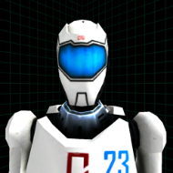  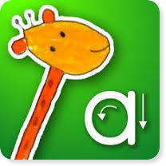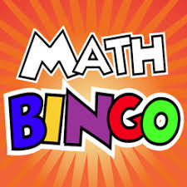
Additional activities | Here are some additional activities for your child to complete should they finish the daily activities provided.  - Practice spelling common exception words,  - Practice 2,5 and 10 times table  - Practice number bonds to 10, and 20  - Practice neat cursive handwriting  There are resources provided to help complete all the activities above. There are also lots of fun learning activities available on Purple Mash for your child to access. Their personal log on is included in the pack.

Ways of getting in touch
If you have any questions about the work provided for your child there are lots of ways you can get in touch. The first option is ‘A Place to Talk’ on our school website. This message is picked up by a senior member of staff and will be passed on directly to your child’s class teacher. Another option is to use the year group email to drop your child’s class teacher an email with any queries you may have.

year1@merseypark.wirral.sch.uk

