Year 3 Pack
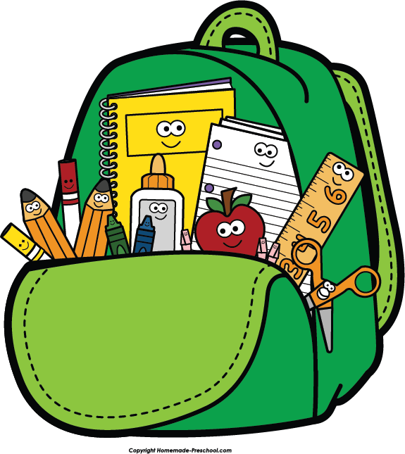
It is important that each day you follow a routine and your child is up, dressed and ready to learn by 9am. Make sure before this they have had a healthy breakfast then find a calm, quiet space for them to start learning, ideally sat at a table. Make sure throughout the day your child has regular short breaks and the opportunity to take part in daily exercises.

Example Timetable and Daily Routine
9:00 | Mindfulness | Start each day with a mindfulness activity (included in pack) which will prepare your child for the days learning.
9:20 | Reading | Follow this with 30 minutes reading either using the books provided, books you have at home or Bug Club (www.activelearn.co.uk). Help your child to apply their reading strategies such as sounding out the word, looking for phonic sounds within the words and breaking the word down into parts.
9:50 | Literacy, Spellings & Grammar | Your child should now settle down to begin completing one of the Literacy tasks (included in pack or on Google Classroom).  If you are unable to edit on Google Classroom – please complete the tasks in your pink home/school workbook.
10:40 | Break | Encourage your child to have a healthy snack and get active for 15-20 minutes. Either take a run around outside or put some yoga (Cosmic Kids Yoga – youtube) or Just Dance Kids (youtube) on and get moving. It is really important for them to take a break and get their heartrate up as this will relax them and get them ready to continue learning.
11:00 | Maths | After an active breaktime your child should settle down again to complete one of the maths tasks (included in pack or on Google Classroom).  If you are unable to edit on Google Classroom – please complete the tasks in your pink home/school workbook.
12:00 | Lunch time | Make sure your child has a healthy, balanced lunch and then gets active again - Cosmic Kids Yoga (youtube) or Just Dance Kids (youtube)
1:00 | Science/Topic | Follow this with a science or topic activity (included in pack or on Google classroom).  If you are unable to edit on Google Classroom – please complete the tasks in your pink home/school workbook.  Our new topic in Science is Light and Shadows and our new Geography topic is Liverpool.  If your child would like to research either of these new topic areas in more detail, please encourage them to do so.  They can be as creative as they like – posters / poetry / art / fact files / diagrams etc

