Mersey Park
Primary School

Say No to Bullying
An information booklet for parents

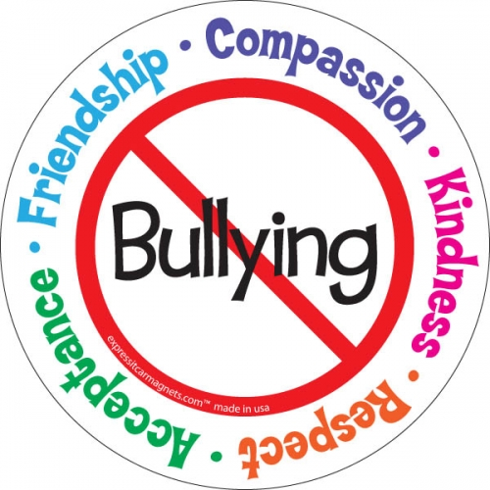

What is bullying?
Throughout school children will learn that bullying is:
- repeated behaviour that happens regularly;
- deliberate. The bully wants to hurt, humiliate or harm the other child;
- an imbalance of power. It involves someone (or a group of people) who are stronger in some way that the person who is being bullied. They may be older, stronger, there may be more of them or they may have a ‘hold’ over the person (e.g. they know a secret about them).

Children will learn that bullying is not:
- a one-off fight or argument;
- when a friend is sometimes thoughtless.

We teach our pupils about four different types of bullying:
- Verbal e.g. hurtful comments and threats, name-calling (this includes Hate Crime - racist and homophobic, biphobic or transphobic comments);
- Physical e.g. hitting, kicking, taking belongings;
- Emotional e.g. staring, glaring, leaving people out, spreading rumours;
- Cyber e.g. using technology to hurt someone through a variety of media – e.g. text messages, comments on social networks.

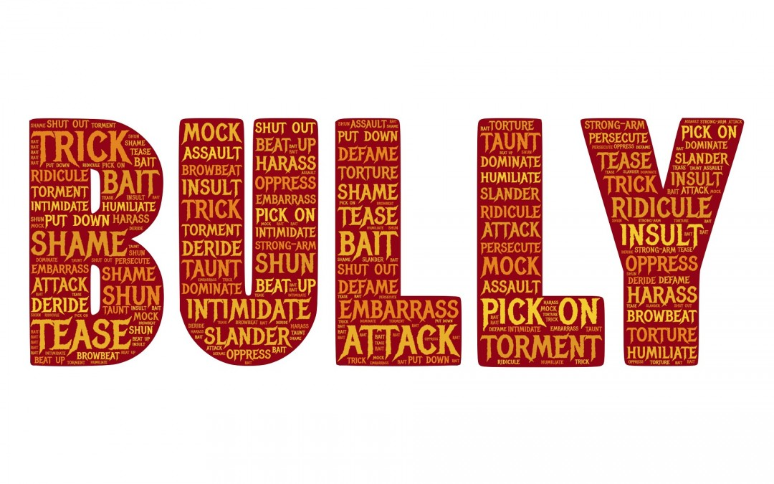

Why do children bully?
Children bully because:
- They don’t realise how much it hurts;
- They dislike or are jealous of someone;
- It makes them feel powerful or respected;
- It gets them what they want (sweets, money);
- They are bullied themselves and are taking out their hurt and anger on someone who won’t fight back;
- They are having problems in their life that are making them feel bad.

REMEMBER:
People who are happy with themselves do not need to bully other people!

What does school do about bullying?

At Mersey Park Primary School we hold an Anti-Bullying week each term:
Autumn term: National Anti-Bullying week theme;
Spring term: Cyber-bullying and e-Safety;
Summer term: Jigsaw PSHE Curriculum.

At school we have an Anti-Bullying policy which explains what to do if bullying is reported and what the school is doing to stop bullying happening in the first place.

This work helps us to stop bullying happening by:

- Making sure that all children and adults mean the same thing when they talk about bullying;
- Helping children to understand how bullying feels for the person being bullied;
- Making sure that all children feel confident about telling an adult when they know that bullying is going on;
- Making sure that all children know exactly what to do if they are being bullied, and feel confident that something will be done to stop it;
- Helping children enjoy, celebrate and respect the ways we are all different, as well as the ways in which we are similar, and to feel good about themselves.

How can I help at home?

The most important things that you can do to help your child to understand, help prevent, and deal with bullying are to:
- Know what your child will be learning about bullying at school (by reading this booklet or looking at the school’s website);
- Encourage and support them to try out the skills they are learning in school;
- Be a good role model in the way you talk about others – so your child will learn that everybody deserves respect;
- Model empathy for others – talk about how other people might feel in different situations;
- Talk openly about what bullying is and how it feels;
- Make it safe for your child to share their worries about bullying with you, so they know they can rely on you to listen to them and support them;
- Talk to your child about the different types of bullying;
- Teach them how to use social media safely, and be a positive role model.

Don’t worry that your children are not listening to a word you say –
worry that they are watching everything you do!

Keep this booklet available for reference – you never know when it could come in handy!

How do I know if my child is being bullied?
If you think your child may be being bullied, look out for:
- behaviour changes,
- withdrawal,
- not wanting to go to school,
- lots of stomach-aches, headaches or non-specific illness.

Sometimes these ailments will be real, and sometimes they may be made-up, but whether the illness is real or not, the worry certainly is, so it needs to be taken seriously.
Help your child to talk to you. Use books and TV plots to open up discussions about bullying. With younger children dolls, teddies or puppets are a good way to help them talk about their worries and feelings.

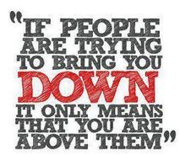

What should I do if I think my child is
being bullied?
Your child may not tell you or us that he or she is being bullied. If you suspect it is happening, look out for the signs (see above).
- Do not get angry or threaten to visit the school or parent of the other child – this will only frighten your child further.
- Praise your child for telling you and reassure them that they have done the right thing.
- Listen to your child, accept your child’s feelings and encourage them to talk about their worries – however minor it may seem to you the feelings are very real for them.
- Don’t jump in with advice or try solve the problem for them. Listen to their ideas, unless they are likely to end up in serious danger or trouble.
- If you tell your child to fight back or say something ‘clever’ to the bullies they may well end up feeling twice as bad. Not only are they being bullied, but they have failed to stop it as well.
- Work doubly hard to help them feel valued and important.
- Help your child to think about what they would like to happen, and ask how you can help—if your child feels in danger, make sure that they have a plan for keeping safe. Avoid the children doing the bullying, e.g. staying with a group of friends, staying in safe areas, knowing who to go to for help etc.
- Tell your child that you have to inform your child’s class teacher at this point and agree how you can do this in the best way so your child does not feel anxious about this happening.

What should I do if my child continues to be bullied?

If the bullying carries on after your child has carried out their own strategies, there are further steps that you can take:
- Collect any evidence e.g. keep a diary of exactly what was said or done, when and where, keep any text messages, emails, or posts on social media.
- Alert the school. Make sure you talk to your child before you do this but be clear that this is what you must do. Agree with your child when is the best time for you to do this – maybe during lesson time or after school.
- When you talk to school please be specific about what has been happening. Ask us what we will do and what we would advise you to do. Remember that we all want the best for your child. We will draw up a plan together with follow up steps.

What should my child do if they are being bullied?

We need to help our children to feel safe to tell us if they know bullying is happening. Children can tell any member of staff in school, they can tell one of our My Happy Mind and Body Ambassadors or they can put a note in a ‘It’s Time to Talk’ box.

What should my child do if they witness bullying?

Talk to your child about what they can do to support a child who is being bullied. They could befriend the child and be kind to them, include them in their games and they must tell an adult what is going on. We complete work in school to teach all children how to be an ‘Upstander’ and not a bystander.

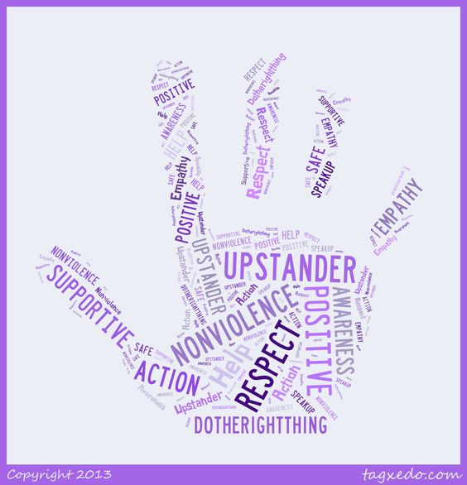

What should I do if my child is bullying others?
If you are told that your child is bullying others don’t immediately dismiss the idea or rush into punishing them. Try not to call them a bully as we are all capable of bullying others.
When you talk stay calm and remind them that it is the behaviour you do not like not them.
Listen to what they have to say. If they deny it, arrange to see the teacher. Stay calm and listen to what the teacher has to say.
Talk to your child about how the other person feels– they may not realise how much they are hurting, frightening or upsetting the other person.
Help your child to develop confidence to make friends – happy people don’t need to bully others.

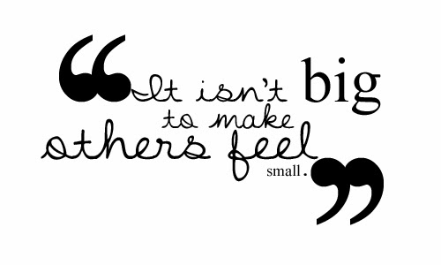

Why don’t schools just get rid of bullies?
Parents are often surprised when schools don’t automatically exclude children who are bullying others. As parents our first concern will always be for our own child’s safety and happiness.
There are three reasons why schools don’t automatically exclude bullies:
- If schools excluded every child who has ever bullied that would include many children. Many children in every school have either been bullied, seen bullying or bullied themselves. There is no evidence that children are born bullies or victims– they change roles according to where they are and who they are with.
- If schools simply moved the problem onto another school others will continue to suffer. The best thing to do is to deal with the problem and try to stop the child from bullying altogether. The school will always have the right to exclude them if the behaviour does not improve following all necessary actions.
- There are always ways of changing bullying behaviour. Helping the bully to understand how the other child is feeling and the effect of bullying on them, teaching them to stand up to peer pressure from others, giving them support to manage the problems they are facing in their own lives– all of these things can change bullying behaviour for good.

Try to understand what we are doing at school and why. When children who are bullied are asked what they want to happen they very rarely mention punishing the other child or revenge, they almost always say:
‘I just want it to stop.’

More information can be found on the school’s website in the Anti-Bullying section, including the school’s Anti-Bullying Policy and the Pathways of Help that school follows when dealing with incidents of bullying.
http://merseyparkprimary.co.uk/
There are also lots of examples of work that pupils have completed during our Anti-Bullying Weeks.
These websites also offer useful information about how to deal with bullying, for parents:
www.kidscape.org.uk
www.childline.org.uk
www.bullying.co.uk
www.anti-bullyingalliance.org.uk
www.nspcc.org.uk

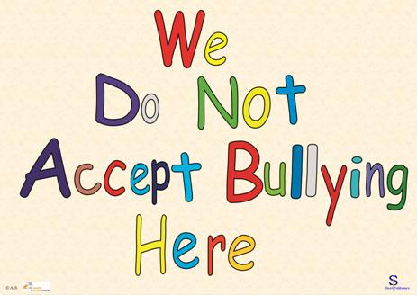

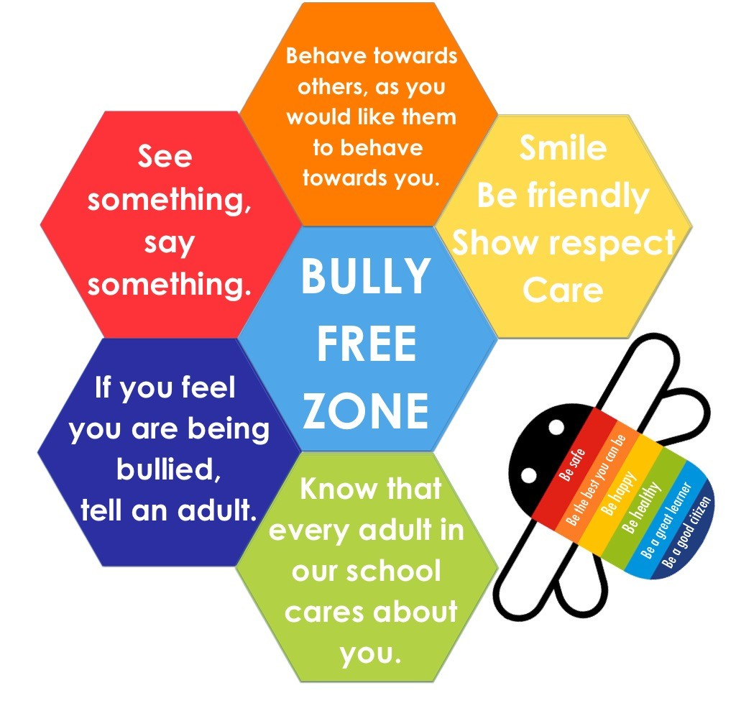

Produced by
Mersey Park Primary School
with input from
pupils, parents/carers, staff and governors

