**Year 1 Snow Day Learning Challenges**

Literacy

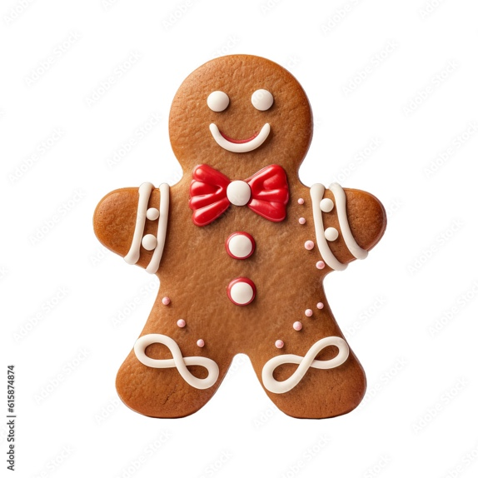

Following on from our new Literacy story ‘The Gingerbread Man’, can you design/draw your own and add some descriptive labels using plenty of power adjectives.

For example, ‘red, shiny bow’ and ‘white, tiny eyes’

*Challenge* – Can you put them into super Year 1 sentences? (Don’t forget our non-negotiables!)

Maths

Using our mathematical knowledge of addition, complete the Gingerbread Man maths questions below.

*Challenge* – Can you make your own addition number problem?

Reading

Topic

Thinking back to our seasons topic, take a look outside or out your window, what signs of winter can you spot?

Can you draw a winter themed picture with all the signs we might see e.g. snow, bare trees, children wrapped up warm.

We can’t wait to hear all about your snow day and look forward to seeing your completed work once we are back in school!

Miss B Jones and Mrs Jennings