**Year 1 Snow Day Learning Challenges**

**Day 2**

Literacy

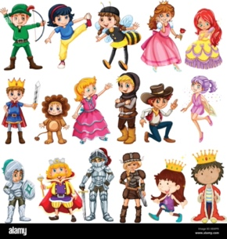

After doing a brilliant description of our Gingerbread Man yesterday, can you create your own new character? It might be a giant, scary monster or a magical, pretty unicorn. Have a go at designing your own and label it using plenty of power adjectives.

*Challenge* – Can you put them into super Year 1 sentences? (Don’t forget our non-negotiables!)

Maths

Using our knowledge of the number bonds to ten, complete the addition questions below.

*Challenge* – How many different ways can you write your number bonds to 10?

Reading

Read the text in the middle and answer the following questions:

Topic

*Weather around the world.*

With an adult’s help, using a device that can access the internet, research the weather and temperature in the UK, Antarctica and Kenya.

Record your findings and compare them. Are they different or the same? Why might this be? Think about our knowledge of the equator/ North pole/ South Pole and how this affects weather around the world. Discuss with an adult.

Make sure you keep wrapped up and warm and we can’t wait to see you in school on Monday!

Miss B Jones and Mrs Jennings